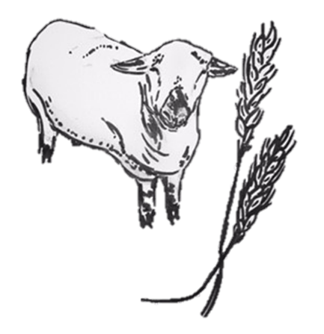Petersfield Autumn Show

A Brief History

Founded in 1892: 3 farmers; Albert Woolland from Ryefield, Herbert Chalcraft of the Brows, Liss and Reg Marshall of Slade Farm, Rogate often used to frequent the Red Lion together in Petersfield, and each would state that they could grow the best quality and biggest mangolds. We can only assume bets were placed and the word spread. Because in September 1892, G Mitchell of Upper Adhurst wrote a letter in the Hants & Sussex news stating for a public meeting to be held on the 1st October to see whether their was sufficient local support for a show to be held.

Capt. the Hon. SH. Jolliffe consented to take the chair. Seedsmen of the day; Toogoods of Southampton, Suttons of Reading, Carters of Raynes Park, and also Fertiliser companies, played a great part in sponsoring classes for produce grown with their seeds etc.

The meeting on October 1st was held and well attended by local dignitaries and farmers who promised their support. After a short speech Mr Mitchell proposed that a show be held and after being seconded by Mr Mark Laker, the proposal was carried. Capt. Jolliffe was elected President, Mr Mitchell Secretary and a committee appointed. It was decided that the show would be a two day event and that a dinner be held. And so, the Petersfield Autumn Show was formed.

Over the past 130 years the club has been through prosperous and difficult times. It has been stopped from running 3 times; WW1, WW2 and most recently Covid.

It was documented that in 1922 they ran 118 classes including 31 for poultry. In 1928 the introduction of wheat and barley classes, saw the beginning of how the competitions are run today. Up until 1960s it was compulsory to enter the mangolds/roots class, so if you didn’t have roots you couldn’t enter any of the other competitions.

The competitions have evolved from; Hops, pulled roots vegetables, fruit, butter, honey, eggs poultry and acreage root classes for swedes, mangolds, and turnips in 1912 to milling wheat, feed wheat, malting barley, milling oats, conservation, diversification, grass, maize, sheep, beef, dairy and the overall farm classes we have had for the past 20 years.

Our membership over the 130 years has fluctuated, as have the entries to the competitions. But in any instance of membership waning or lack of competition entries, the committee has rallied and pulled in new members and kept the club and the competitions going. There have been collaborations over the years with the ploughing match and Growmore clubs. The social dinners and AGMs have been a mainstay in the farming community calendar, it has been recorded that some great entertainers and bands have attended. In later years the club has added in a farm walk and summer BBQ, which has proved popular and a chance for all the farmers to get together before the harvest.

With some families now into their 4th generation of membership, the Petersfield Autumn Show is a farming heritage that our local community still rely upon, even if that is still the same ethos as Wolland, Chalcraft and Marshall had in 1892, where we all think our field of wheat is better than our neighbours!